ServiceNow Project Report
Bonam Venkata Chalamayya Engineering College, Odalarevu

Project Title: Laptop Request Catalog Item
Team Details:
- Team ID: LTVIP2026TMIDS71863
- Team Size: 4
- Team Leader: Syam Viswa Teja Kadiyala
- Team Member: Swathi Rokkala
- Team Member: Tadala Durga Devi
- Team Member: Thirumalavasu Kopanathi

Project Report
Project Title:
Laptop Request Catalog Item

Objective:
The objective of this project is to create a Laptop Request Catalog Item in ServiceNow using Update Sets. The project demonstrates creating catalog items, adding variables, implementing UI Policies and UI Actions, exporting update sets, retrieving them in another instance, and testing the complete functionality.

Project Steps:
1. Update Set
a. Create Local Update Set
2. Service Catalog Item
a. Create Service Catalog Item
b. Add Variables
3. UI Policy
a. Create Catalog UI Policies
4. UI Action
a. Create UI Action
5. Export Update Set
a. Export changes to another instance
6. Login to Another Instance
a. Retrieve the Update Set
7. Testing
a. Test the Catalog Item

1. Update Set
a. Create Local Update Set

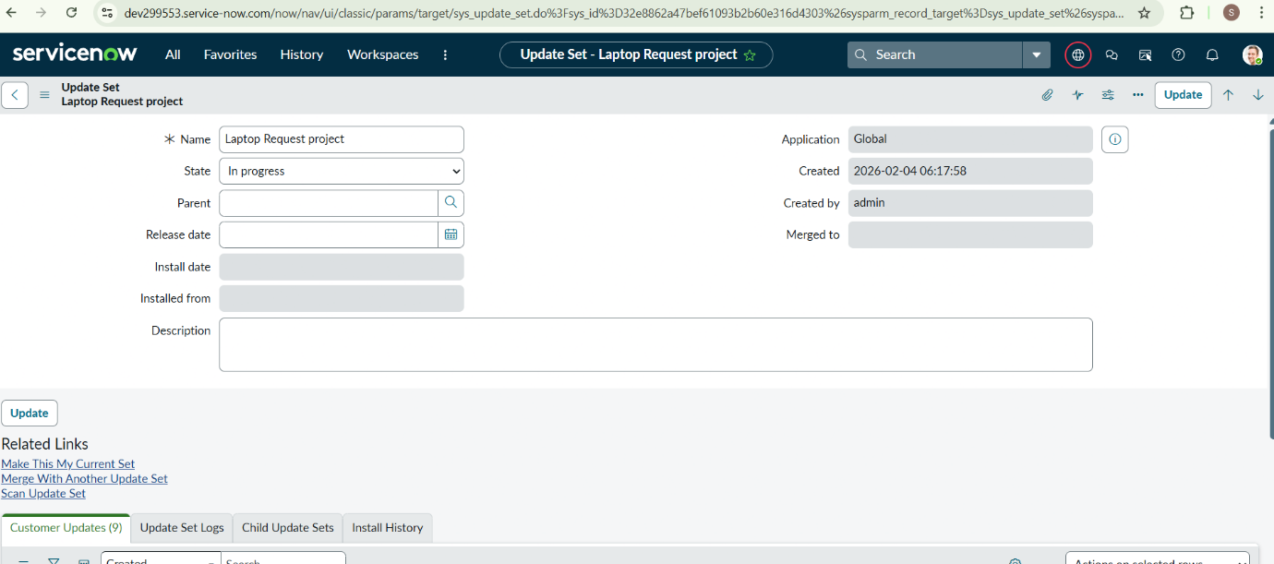
2. Service Catalog Item a. Service Catalog Item 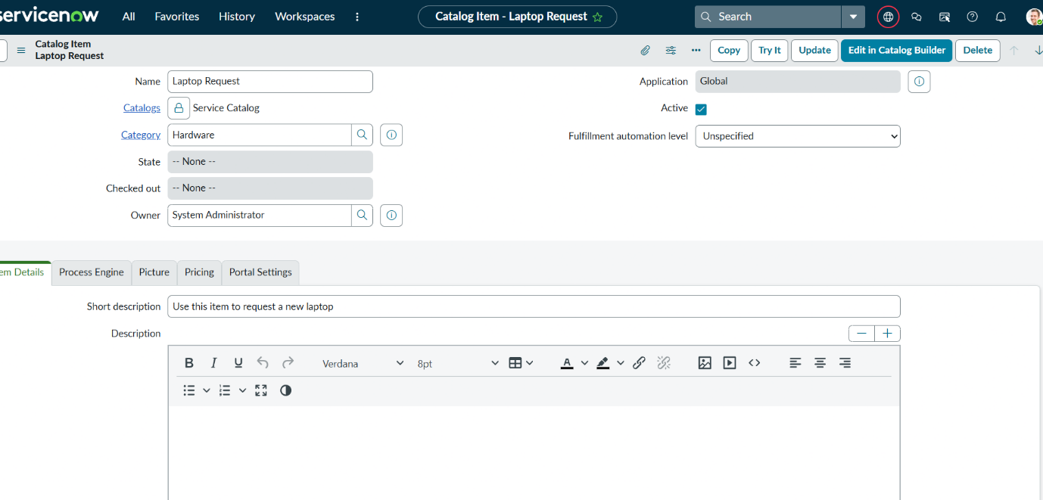

b. Add variables
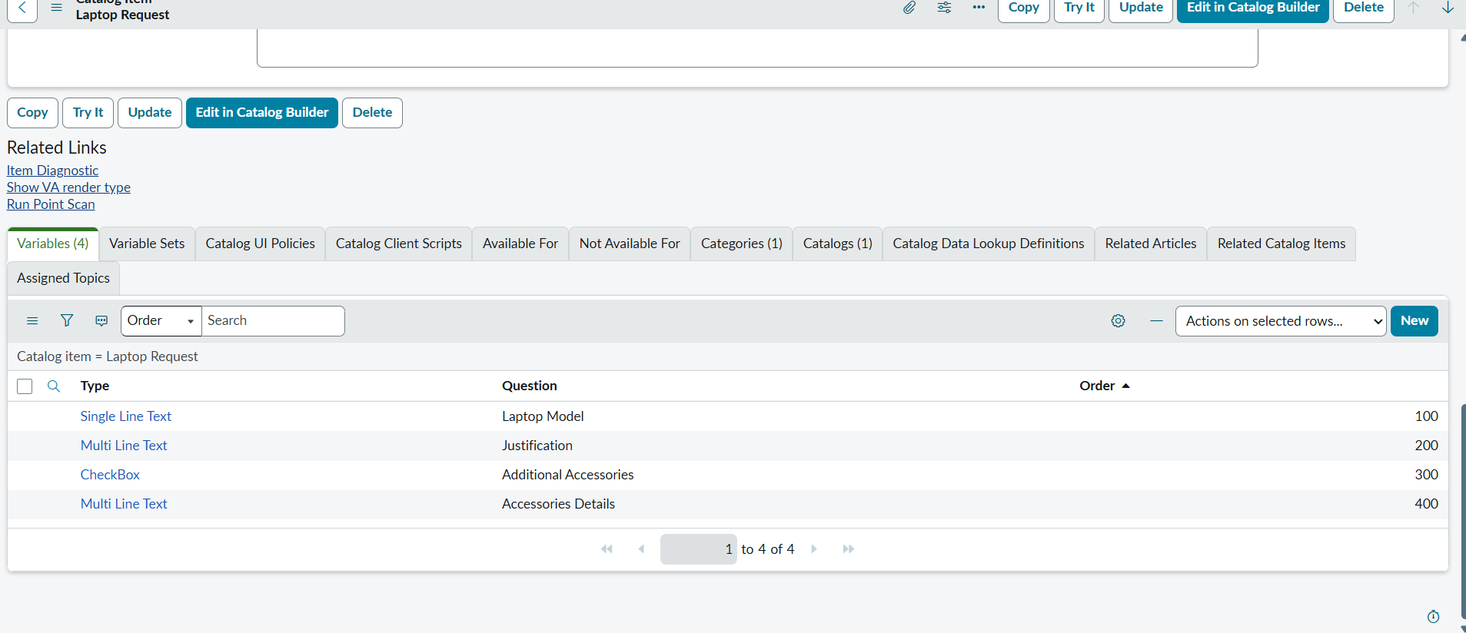

3. UI Policy
a. Create Catalog Ui policies
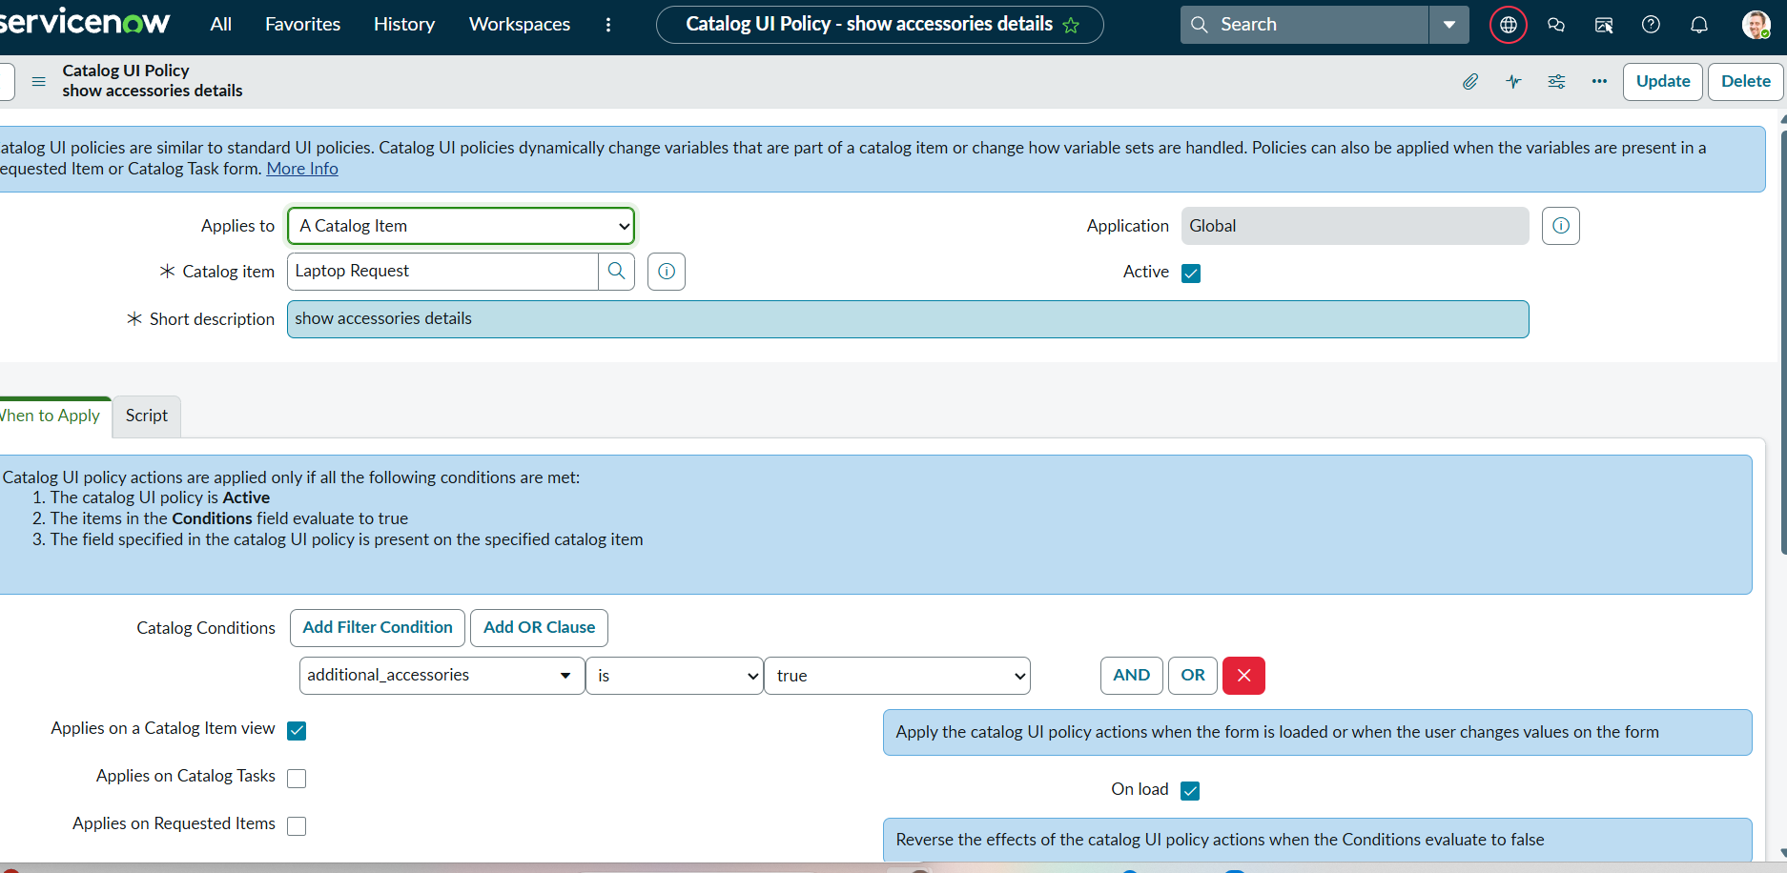

4. UI Action
a. Create ui action
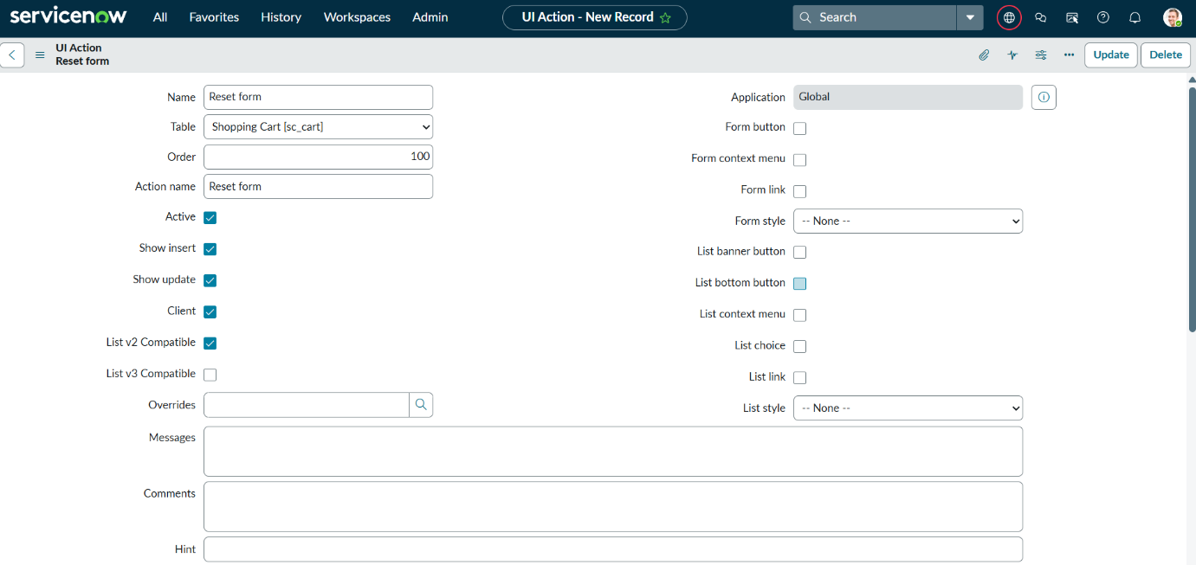

5. Export Update set
a. Exporting changes to another instances
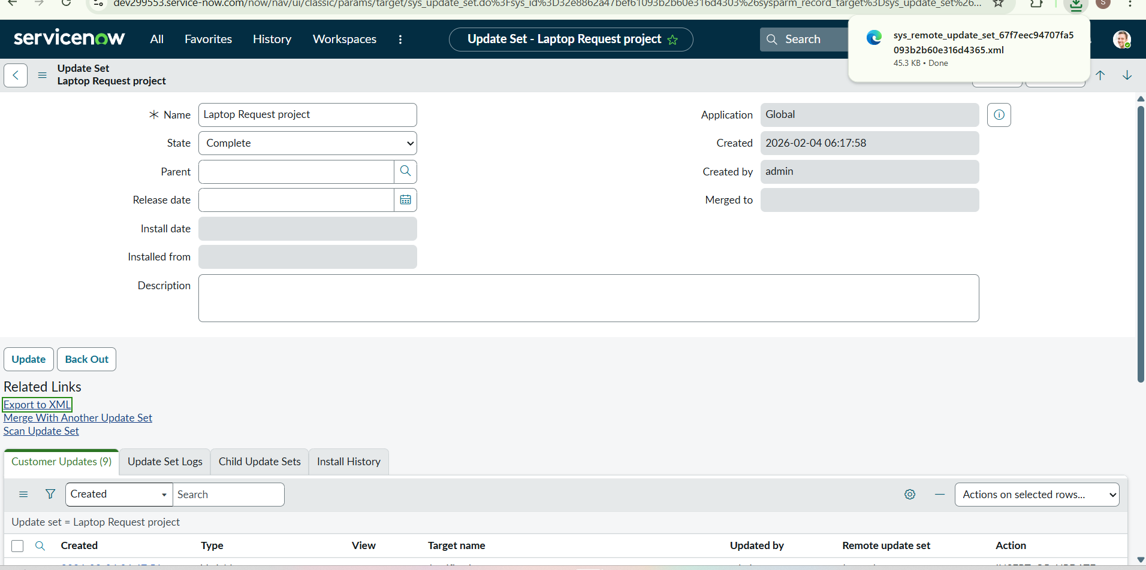
6. Login to another Instance
a. Retrieving the update set
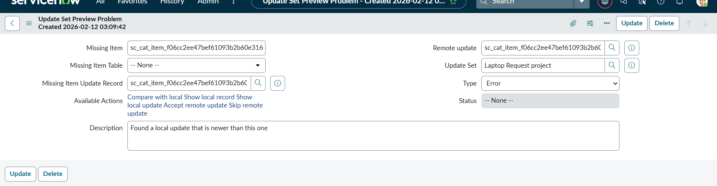
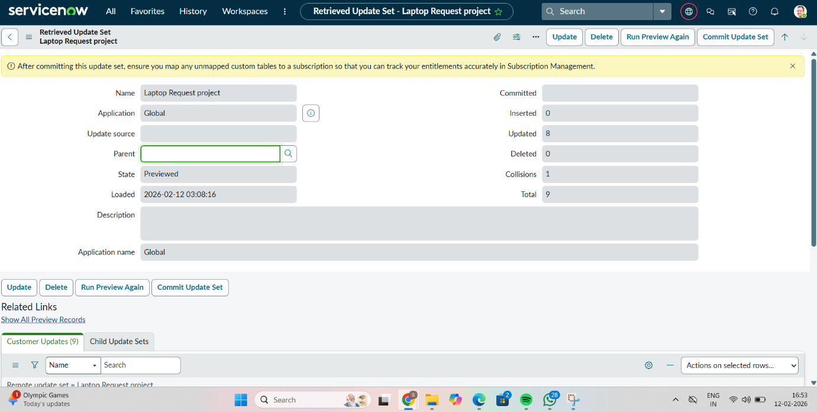
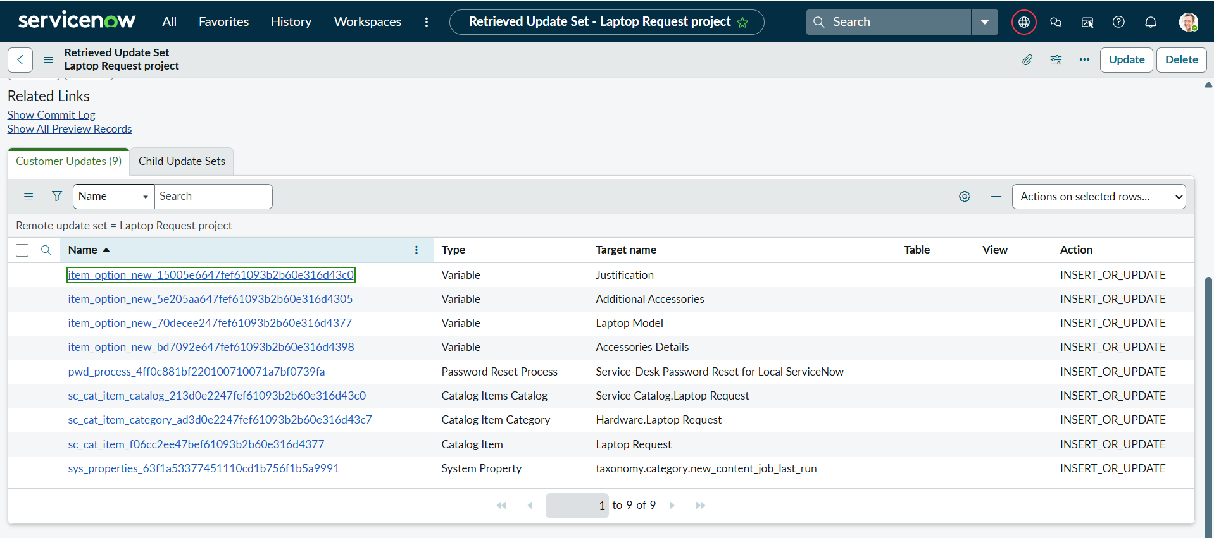
7. Testing
a. Test Catalog Item
